Mathematical Trading Strategies

Assignment 1

|  | ^DJI | ^FCHI | ^KS11 | ^RUT | ^XAX |
| --- | --- | --- | --- | --- | --- |
| Volatility | 0.169167 | 0.202544 | 0.162076 | 0.226480 | 0.192963 |
| Sharpe Ratio | 0.002337 | 0.001294 | 0.001015 | 0.001750 | 0.001612 |
| Sortino Ratio | 0.003580 | 0.002038 | 0.001589 | 0.002742 | 0.002483 |
| Max Drawdown | -0.370862 | -0.385585 | -0.438979 | -0.430613 | -0.535116 |

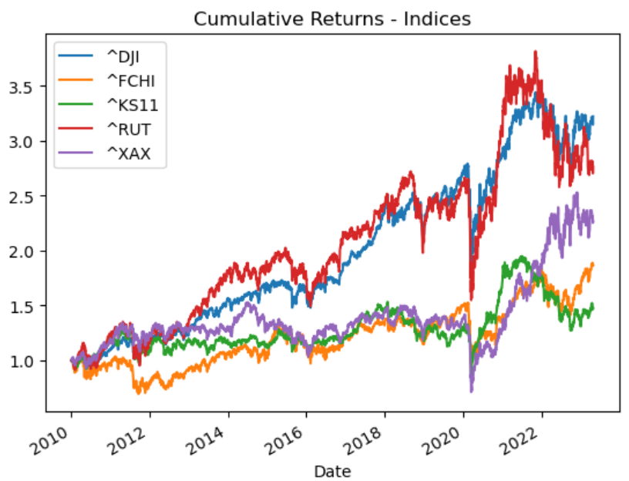

|  | AAPL | AMZN | GOOGL | MSFT | RY |
| --- | --- | --- | --- | --- | --- |
| Volatility | 0.286001 | 0.331799 | 0.272976 | 0.261395 | 0.209038 |
| Sharpe Ratio | 0.003971 | 0.003136 | 0.002642 | 0.003447 | 0.002004 |
| Sortiono Ratio | 0.006634 | 0.005318 | 0.004422 | 0.005786 | 0.003202 |
| Max Drawdown | -0.437972 | -0.561453 | -0.443201 | -0.371485 | -0.399540 |

